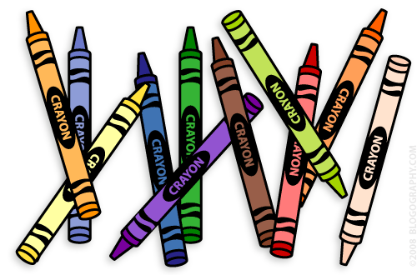**Our 1st Grade Classroom News**

**The Week of Apr. 3rd – 7th**

**Email:** [**Lweeks@bluevalleyk12.org**](mailto:Lweeks@bluevalleyk12.org)

**Website:** [**www.bluevalleyk12.org/hes/lweeks**](http://www.bluevalleyk12.org/hes/lweeks)

**Important Info**

**Upcoming Events**

* We will be working on abbreviations this week!

-Field Day t-shirt order forms were sent home a while ago and are due on Wednesday, April 19th.

- MAP testing will be this week (our math MAP testing date has changed from last week’s newsletter). Students will be tested for math on Wednesday and reading on Friday. Please be sure your child gets breakfast and a good night sleep on those days to help them prepare to do their best on these tests! I know they will do great!! The kids are excited to show what they know! ☺

**Math Challenge of the Week:** I am teaching the students a little bit about fractions now to prepare them for MAP testing but this is something that could be done at home as well. Have your child draw each of these shapes 2 times. Then have them split the shapes into halves and fourths and label each one after coloring in a section. **The shapes they need to draw are circle, square, and rectangle.** Here is an example of what they need to do but with a different shape:

   
 **Reading Challenge of the Week:**  Have students find words with prefixes in it and have them write them down. They can underline the prefix in each word they find. (ex: unhappy, restock, disapprove). Then have them come up with a definition for the word. For example: rewind- wind again  
  
**Writing Challenge of the Week:** Do either the reading or math challenge of the week this week! ☺

**Challenges of the Week**

**Apr. 17th** Field Trip to Folly Theater

Harmony 25th Anniversary (4-7pm)

**Apr. 18th** Early Release Day

**Apr. 19th** Field Day t-shirt order forms are due

MAP testing – math (pm)

**Apr. 20th** 1st Grade Musical @ 2:45 in the Gym

**Apr. 21st** MAP testing – reading (am)

**Apr. 24th** No School

**May 1st** Reading charts due

**Tech of the Week**

**-** [**http://kids.nationalgeographic.com/**](http://kids.nationalgeographic.com/)is a great one for those that like non-fiction reading. LOTS of fun information and research resources for them!

-[**Geoboard**](https://itunes.apple.com/us/app/geoboard-by-math-learning/id519896952?mt=8)is a great app to practice shapes and other mathematical topics. We have been learning a lot about different shapes and angles so this is a great one to add right now! There are a lot of options for the kids to use on it too. It is free!